Houston County Landfill

FIS ID: 10359

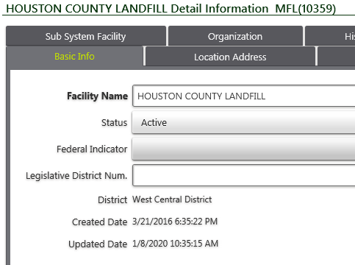

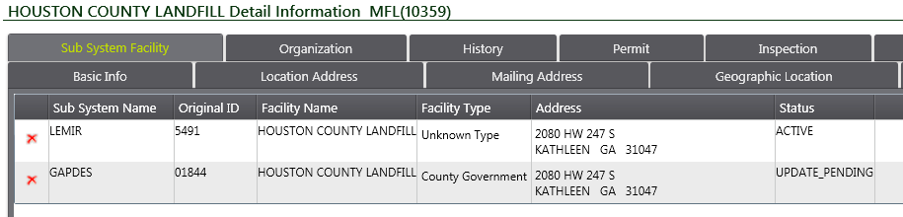

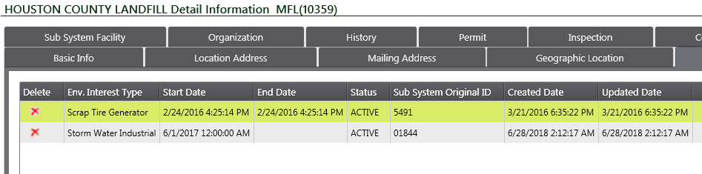

FIS ID: 34840

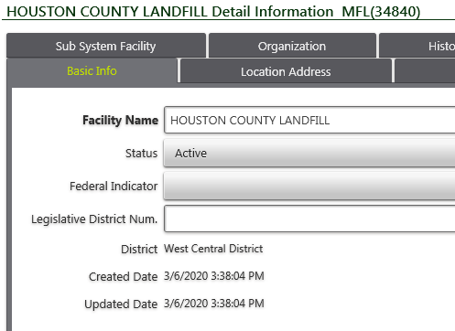

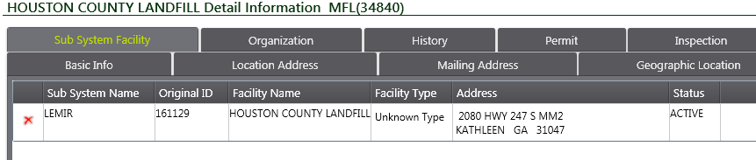

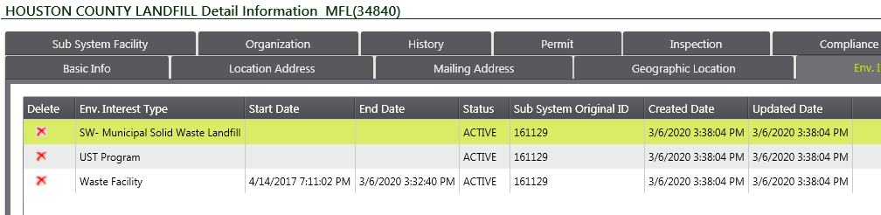

FIS ID: 6431

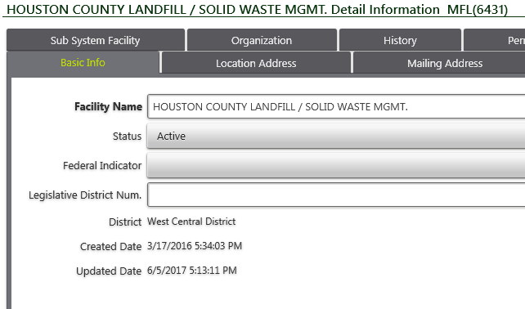

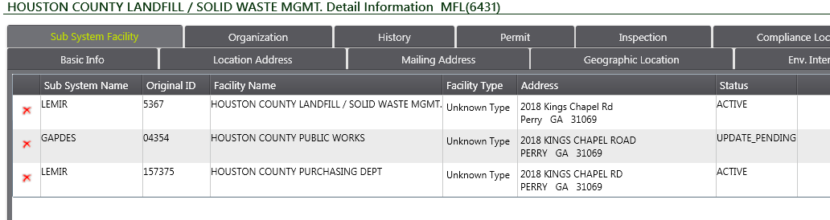

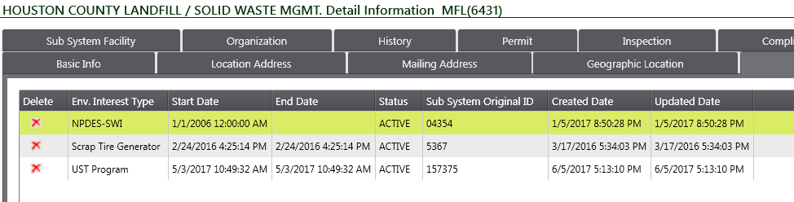

GEOS ID: 4336 -- HOUSTON COUNTY LANDFILL

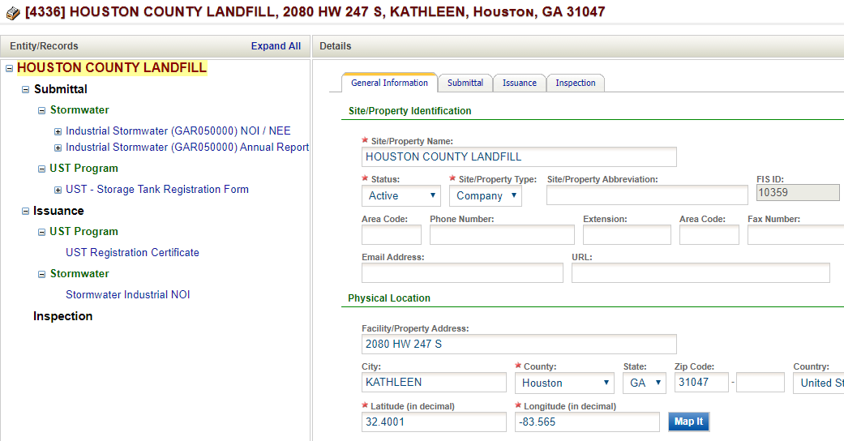

No SW permits or submittals… Only UST and Ind. Storm water

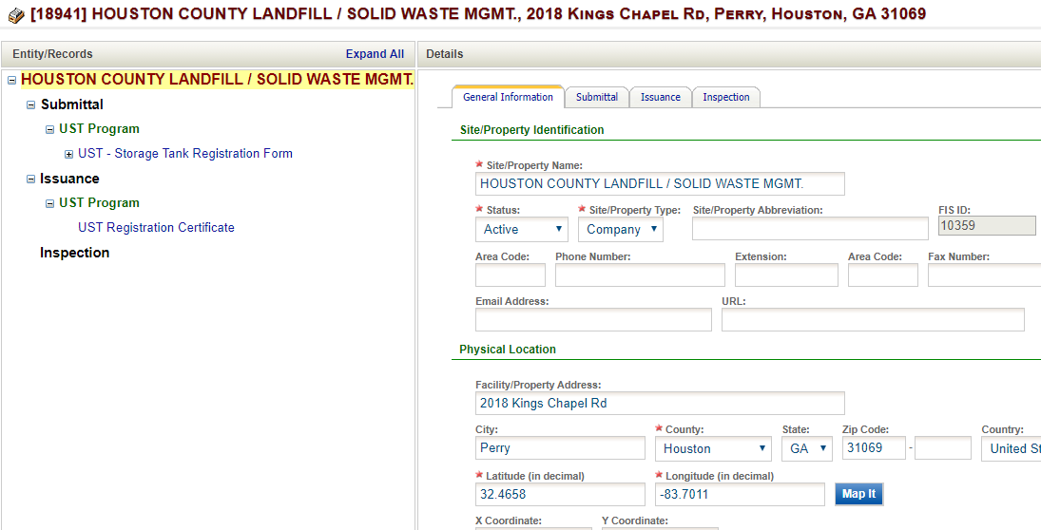

UST ONLY

GEOS ID: 270474… New Fac. Created by Mike

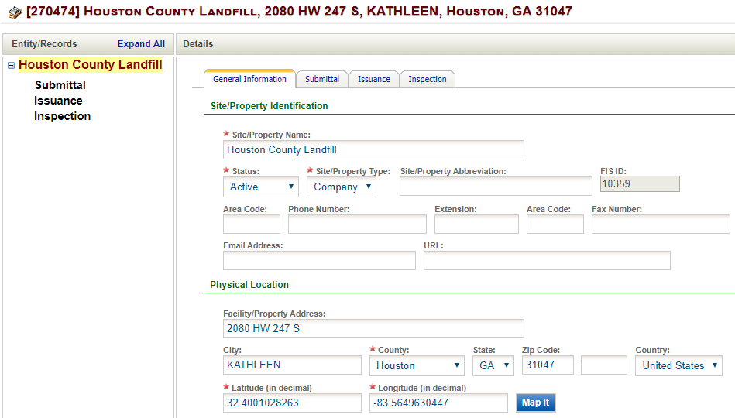

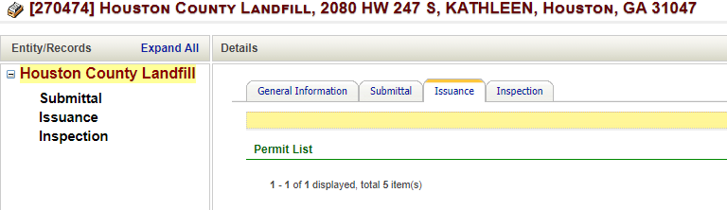

Shows no Permits or submittals, but says linked to 5 permits (probably through common FIS ID)

LEMIR ID: 5491 -- Houston County Landfill

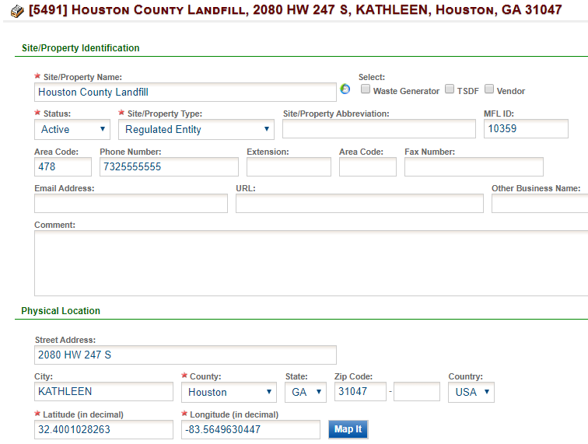

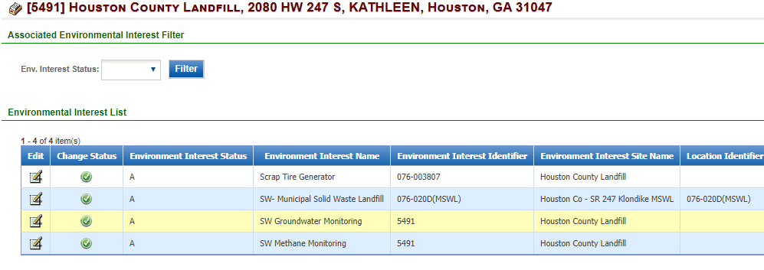

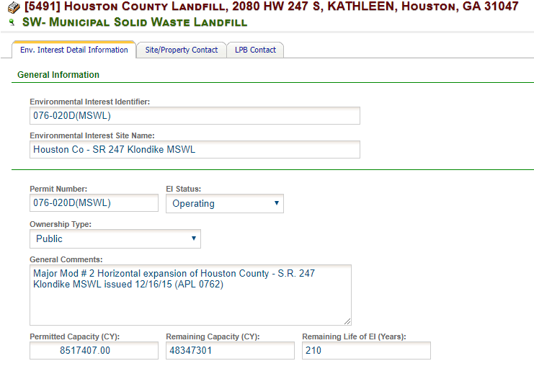

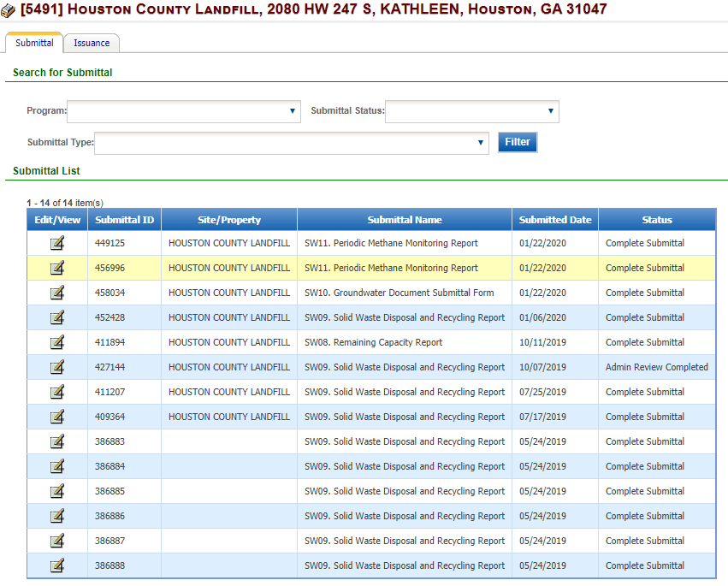

LEMIR ID: 161129

